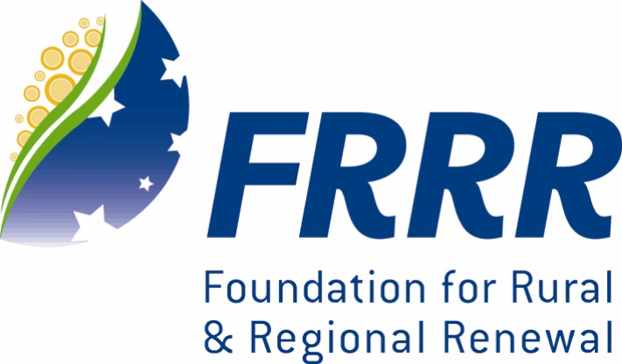
SMALL GRANTS FOR SMALL RURAL COMMUNITIES

GUIDELINES Round 20, 2011

A collaborative program supported by The William Buckland Foundation, R.E. Ross Trust, Perpetual Trustees, The Yulgilbar Foundation, The Edward Wilson Trust,
The Cages Foundation, Sid & Fiona Myer Family Foundation, The Becher Foundation
and The Foundation for Rural and Regional Renewal (FRRR).
This program is administered by FRRR.

This small grants program will offer up to $400,000 in grants to benefit people in small rural and remote Australian communities.

What can be funded?
- Not-for-profit Organisations can apply for projects and activities that offer clear public benefit for communities living in small rural and remote locations in Australia, contributing to their development in social and community welfare, economic, environmental, health, education or cultural areas.
- Applications from communities with a population of 10,000 or less will receive priority.
- Grants will be made in amounts up to $5,000.
- To be eligible, projects must be for a charitable purpose (benefit the whole community). The majority of funds are unrestricted but, as this is a collaborative program, some grants may be restricted to Tax Concession Charity (TCC) organisations or must be granted within specific geographic locations.
- Organisations should have an ABN or Incorporation Certificate.
- Organisations demonstrating community partnerships will be preferred to multiple applications from one community.

What can not be funded?
- Operational and administration costs, travel and accommodation will not be funded
- Previous grant recipients who have not completed final report requirements will not be considered for further funding
- The encouragement or advancement of sport, recreation and social activities is not considered a charitable activity by the Australian Taxation Office. Applications from sporting organisations need to clearly demonstrate a benefit to the wider community.

Currently, preference will be given to projects that support:
- Activities that support education and youth
- Culture, arts, tourism and community heritage
- Communities from areas that are Natural Disaster Declared
- Community infrastructure such as historic community halls
- Communities in the Benalla area (Victoria), Taree area (NSW) and Berrembed, Matong & Grong Grong area (NSW)

Please submit your application before 5pm Friday 30th September 2011.
Post: FRRR, Small Grants for Small Rural Communities, PO Box 41, Bendigo, Vic 3552
Email: info@frrr.org.au

Enquiries can be made on freecall 1800 170 020 or email info@frrr.org.au

Please use the attached application form and keep responses to the space provided.
Attach a copy of your most recent Financial Statement and Detailed Project Budget.

SMALL GRANTS FOR SMALL RURAL COMMUNITIES

APPLICATION FORM – Round 20, 2011

A collaborative program supported by grants from The William Buckland Foundation, R.E. Ross Trust, Perpetual Trustees,
The Yulgilbar Foundation, The Edward Wilson Trust, The Cages Foundation,
Sid & Fiona Myer, The Becher Foundation, The Myer Family,
and The Foundation for Rural and Regional Renewal.

OFFICE USE ONLY;
PREV APP Y N
SUCCESS Y N
FINAL REPORT Y N
AG ANZ AP CARA CATCH GARD MCEWEN REP SG REACH
GST TTC DGR

Organisation Name:

Organisation Head Name: Mr/Mrs/Ms/Miss (name)
Position Held:
Daytime Phone No: ( ) Mobile:
E-mail:

Postal Address of Organisation:

Contact Person Name: Mr/Mrs/Ms/Miss (name)
Position Held:
Daytime Phone No: ( ) Mobile:
E-mail:

ABN / INC No: (please provide number or other proof of incorporation)

GST - Registered yes no

TCC – Tax Concession Charity yes no provide copy of ATO endorsement

DGR – Deductible Gift Recipient yes no provide copy of ATO endorsement

Project Title:

Grant Amount Requested:
$
(Up to a limit of $5,000)
CATEGORY WHICH BEST DESCRIBES YOUR PROJECT: (Please tick one ONLY)
Culture Economic Education Environment Social Health

AREA BEING ADDRESSED: Please Tick
Education & Youth Culture, Arts Tourism & Community Heritage Natural Disaster Declared
Community Infrastructure Benalla Area Taree Area Berrembed/Matong/Grong Grong

What is the Population of your town?

Location / proximity to nearest Capital City (eg 90km NE of Perth):

Please contain responses to the box sizes provided.

BRIEF DESCRIPTION OF THE MAIN FEATURES OF YOUR COMMUNITY

WHAT DOES YOUR ORGANISATION DO? (Please provide a brief overview e.g. mission, founding date, major programs and distinctive organisational attributes, number of members, number of staff and/or volunteers)

WHAT WOULD YOU LIKE THE GRANT FOR? (Please describe the project and the need it aims to meet and who it will benefit)

HOW MUCH WILL IT COST? (Please provide a detailed project budget e.g. is it part of a bigger project? Who else have you sought funds from? Quotes provide good evidence to support the budget)

Income | $ | Expenditure | $
FRRR grant request
In-Kind Support |  | In-Kind Support
TOTAL: | $ | TOTAL: | $
Does the Amount Requested cover the full project cost? Y / N
WHEN WILL THE PROJECT HAPPEN? (Please outline the expected date that this project would become operational and then completed)

HOW WILL THIS BENEFIT YOUR COMMUNITY AND HOW WILL YOU MEASURE YOUR SUCCESS?

YOUR FINANCIAL INFORMATION

Please attach a copy of the most recent financial statements.
ie. Most recent Bank Statement / Balance Sheet / Profit & Loss Statement

PLEASE ENSURE YOU HAVE COMPLETED / ATTACHED THESE ITEMS IN YOUR APPLICATION:

- Project Category
- Population
- Location
- Financials
- Project Budget & Quotes
- Certificate of ABN or Incorporation

PLEASE DO NOT BIND YOUR DOCUMENT

In signing this application the below terms are agreed to:
I/We acknowledge and understand that all applications become the property of FRRR.
I/We agree that FRRR may provide this application to other potential funding sources.
I/We agree to inform FRRR if the organisation has a significant change in financial situation.
I/We agree, if successful, to expend any funding within 12 months
I/We agree for FRRR to publish stories of projects funded.

Signed ______________________________________________________________________

Name: ______________________________________________________________________
Title: ______________________________________________________________________

Please submit your application before 5pm Friday 30th September 2011.
Post: FRRR, Small Grants for Small Rural Communities, PO Box 41, Bendigo, Vic 3552
Email: info@frrr.org.au

Enquiries can be made on freecall 1800 170 020 or email info@frrr.org.au

