
Enrolment Form

ALLAN SAVORY’S HOLISTIC MANAGEMENT®
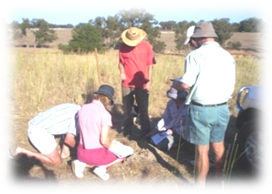

WAGGA Program: March & April 2012

March 22 & 23 Introduction Module

March 28 & 29 Grazing Module
April 19 & 20 Financial Module

Details on people attending: Names
1. ___________________________________________
2. ___________________________________________

Business Name and contact details:
Trading Name: __________________________________________
Postal address:___________________________________________
___________________________________________
Phone: ___________________________________________
Fax: ___________________________________________
Email: ___________________________________________
Note: For eligible landholders who have been approved, the Murrumbidgee CMA will cover all course costs. Please discuss this funding with Mark Gardner prior to commencing the course. The venue for this course will be the Riverina Community College on Murray St, Wagga.
Each day will begin at 9am and finish at 4pm.


Please email or fax this completed form back to Vanguard Business Services, Dubbo. If you have any questions please do not hesitate to ask us.
Mark is an Accredited Associate in Allan Savory’s Holistic Management®. This is your guarantee of quality, professionalism and ethics.
Email: mark.gardner@vbs.net.au
Fax: 68 85 5737
Phone: 68 85 1925

