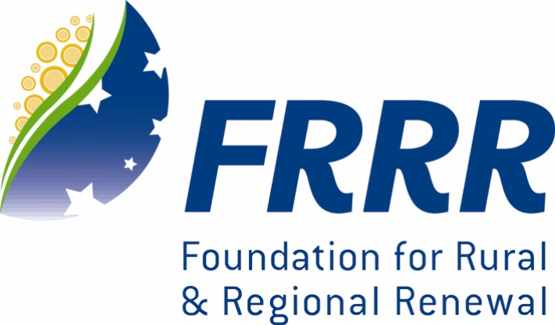

SMALL GRANTS FOR

SMALL RURAL COMMUNITIES

Guidelines Round 21, 2012

A collaborative program supported by The William Buckland Foundation, R.E. Ross Trust, Perpetual Trustees, The Edward Wilson Trust,
The Myer Foundation, The Pratt Foundation, The Sylvia & Charles Viertel Charitable Foundation and The Foundation for Rural and Regional Renewal (FRRR).

This program is administered by FRRR.

This small grants program will offer up to $400,000 in grants to benefit people in small rural and remote Australian communities.

What can be funded?
- Not-for-profit Organisations can apply for projects and activities that offer clear public benefit for communities living in small rural and remote locations in Australia, contributing to their development in social and community welfare, economic, environmental, health, education or cultural areas.

- Applications from communities with a population of 10,000 or less will receive priority.

- Grants will be made in amounts up to $5,000.

- To be eligible, projects must be for a charitable purpose (benefit the whole community). The majority of funds are unrestricted but, as this is a collaborative program, some grants may be restricted to Tax Concession Charity (TCC) organisations or must be granted within specific geographic locations.

- Organisations should have an ABN or Incorporation Certificate.

- Organisations demonstrating community partnerships will be preferred to multiple applications from one community.

What can not be funded?
- Operational and administration costs, travel and accommodation will not be funded.

- Previous grant recipients who have not completed final report requirements will not be considered for further funding

- The encouragement or advancement of sport, recreation and social activities is not considered a charitable activity by the Australian Taxation Office. Applications from sporting organisations need to clearly demonstrate a benefit to the wider community.

Please submit your application before 5pm Friday 30th March 2012.
Post: FRRR, Small Grants for Small Rural Communities, PO Box 41, Bendigo, Vic 3552
Email: info@frrr.org.au

Enquiries can be made on freecall 1800 170 020 or email info@frrr.org.au

Please use the Round 21 application form and keep responses to the space provided.
Attach a copy of your most recent Financial Statement and Detailed Project Budget.

