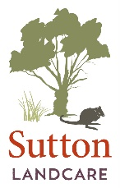
NEXT SUTTON LANDCARE MEETING Tuesday 8 August 2017
Reintroduction of native animals to Mulligans Flat Woodlands Sanctuary
Sutton Landcare Group will next meet at 7:30pm on Tuesday 8 August 2017 at Sutton Public School.
Dr Will Batson, recently-appointed Sanctuary Manager of the Mulligans Flat Woodland Sanctuary will address us on native animals being re-introduced to the Sanctuary. They include Eastern Bettongs, Eastern Quolls, Bush-Stone Curlews, New Holland Mice, the Brown Treecreeper (a bird) and the Southern Brown Bandicoot.
The ACT Government announced in June 2017 that around $900,000 had been allocated to triple the size of the Sanctuary to 1200 ha of predator-proof woodland. This is an exciting development.
After the presentation there will be a short discussion, followed by supper. Everyone is welcome. Further details on Sutton Landcare Group may be found on our website or by contacting our secretary (Marchien Van Oostende on 0402 986 934 or emailing sutton.landcare@gmail.com).
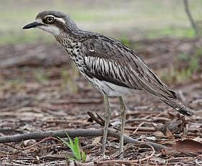
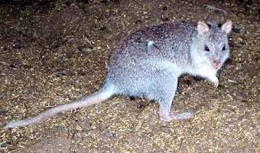

Eastern Bettong Bush-Stone Curlew
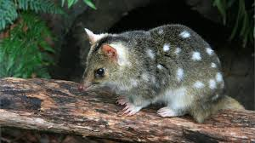
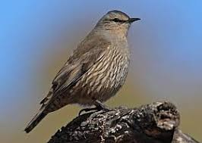
Brown Tree Creeper Eastern Quoll

