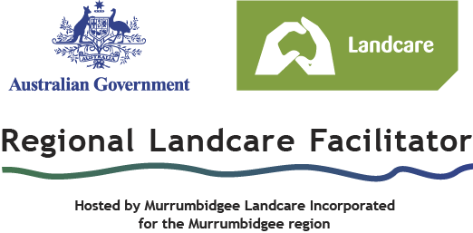
31st January 2012

Dear Murrumbidgee Landcarers,

Murrumbidgee Landcare Inc and your Regional Landcare Facilitators would like to invite representatives from your Landcare group on a Landcare road trip to attend the 2012 Central NSW Futures Forum: Biodiversity Pays on Thursday and Friday 1st and 2nd of March 2012.

The Forum will discuss the production, financial, and biological benefits of maintaining and improving biodiversity on farms. Speakers will include renowned ecologist Professor David Lindenmayer, journalist Robyn Williams, leading scientists from CSIRO and the Australian National University, and many others. Thursday evening will include an optional cocktail party, and there will be site visits on Friday to the properties of inspirational local farmers, who will share their stories of both failure and success in their efforts to combine biodiversity conservation with productive cropping and grazing. Please see the attached program for further information.

Forum registration is being offered at an Early Bird price of $75 per person until February 14th, after which it will rise to $100 per person. You can register using the attached registration form or online at the Sustainable Cowra website (http://www.sustainablecowra.com.au/ -the forum link is in the top left-hand corner). We ask that registration and accommodation costs be covered by the Landcare group, or by the individuals wishing to attend. All registrations close on Friday February 24th.

A mini-bus will be provided at no additional cost, from Wagga Wagga to Cowra, leaving at 5:30am Thursday March 1st from the Landcare office at the Department of Primary Industries on Pine Gully Road, and returning at 3:30pm Friday March 2nd. Please contact me to organise car-pooling to Wagga if required, and persons living along the route from Wagga to Cowra may be picked up along the way.

This is a prime opportunity to meet with Landcarers from around the region and do a little networking, or just relax in the company of like-minded people.

If a member or members of your Landcare group are interested in attending this event, please contact me on the details below when they have registered. There is limited space on the bus, so places on the bus will be first in first-served. We will need final numbers for the bus by COB Friday February 24th. Please contact me if you have any questions.

Sincerely,

Kimberley Beattie
Regional Landcare Facilitator
kbeattie@murrumbidgeelandcare.asn.au
0487 953 777
Ricegrowers’ offices, Yanco Ave, Leeton

