Biodiversity in the House Paddock
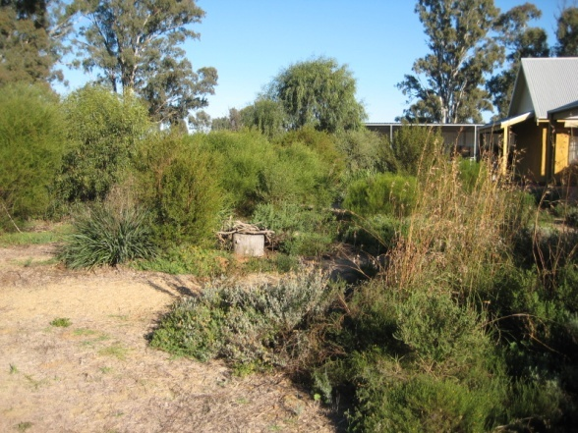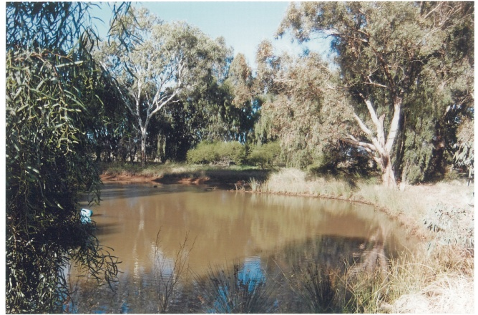
Come and join us on a biodiversity bus tour on
Wednesday May 30th
Spend a relaxing day in the Coleambally district learning how to increase the biodiversity benefits of your house garden and create habitat around your sheds. Visit the properties of local land owners and gardeners and be inspired. Whether you live on a thousand acres or a tiny town block, this bus trip is for you!
Time: 9.30 am to 3.00pm
Where: Join the bus beside the Kidman Way, near the excavator
Guest Speaker: Alison Elvin (Natural Capital)
Cost: FREE! Lunch and light refreshments provided
RSVP: Thursday 24th May

Practical  Beautiful  Biodiverse
For more information and to RSVP contact Regional Landcare Facilitator Kimberley Beattie on 0487 953 777 or kbeattie@murrumbidgeelandcare.asn.au

